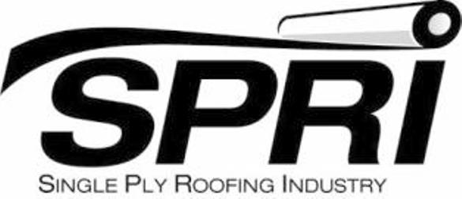

**Field Test Method for Bond Strength of Low Rise Foam Adhesives  
to Various Roof Substrates**

*(Addendum to ANSI/SPRI IA-1, Standard Field Test Procedure for Determining the Mechanical Uplift Resistance of Insulation Adhesives over Various Substrates)*

1. **Introduction**

Requests for field adhesion tests for the attachment of adhered membranes, especially fleeceback membranes, to various existing roof surfaces and monolithic roof decks using low-rise foam urethane adhesives have become more prevalent. SPRI is providing technical guidance that will standardize the test procedure.

Taking into consideration that roof membrane manufacturers have tested their membranes and have known values, this pull test procedure will focus on the adhesion of the adhesive to the various substrates.

To field verify the acceptability of these various substrates, SPRI recommends that a field adhesion test be performed based on ANSI/SPRI IA-1-2010.

**2.0 Testing Procedure**

2.1. Prepare substrate to receive adhesive. The area chosen for the test shall be prepared in the same manner as proposed for the new roofing system’s assembly. Ensure a dry substrate and good weather conditions to match the expected roofing conditions.

2.2 A 24” x 24” (0.6096 m x 0.6096 m) piece of CDX grade plywood minimum 23/32” (18.2 mm) thick is adhered with the adhesive applied according to the adhesive manufacturer’s specifications. Application of adhesive shall be applied equidistantly from the centerline of the test specimen for ribbon applications and full coverage for fully adhered applications. Any excess adhesive application that falls outside the  
24” x 24” (0.6096 m x 0.6096 m) sample area shall be cut away from the test sample to ensure the results are not skewed.

2.3 The assembly shall be allowed to cure at least the minimum time specified by the adhesive manufacturer before the pull test is conducted.

2.4 The field withdrawal test should be performed according to ANSI/SPRI IA-1 2010, *Standard Field Test Procedure for Determining the Mechanical Uplift Resistance of Insulation Adhesives over Various Substrates*.

2.5 Report the maximum value obtained in pounds per square foot (PSF) and the failure mode.

**Note: Consult membrane manufacturer’s product testing for specific data related to ultimate system performance.**

**Disclaimer:** This field test method is for use by architects, engineers, roofing contractors, roofing consultants, owners of low slope roofing systems and their representatives. The results of this test method are not an indication of system performance. SPRI, its members and employees do not warrant that this test method is proper and applicable in all situations and under all conditions.